Bridgend Farmhouse
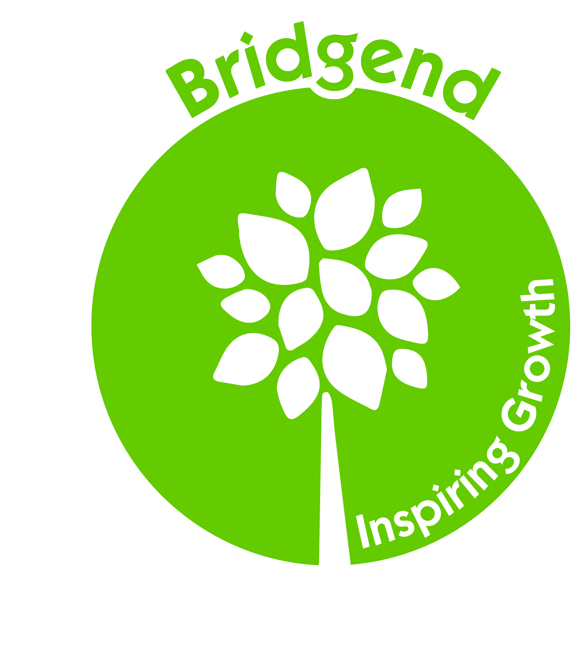

ANNUAL GENERAL MEETING
Charitable Community Benefit Society No. 7683,
Registered Charity Number SC048396

Sunday 16th June 2019
Bridgend Farmhouse
4 – 5pm

AGENDA

- WELCOME

- INTRODUCTIONS

- APOLOGIES

- SHORT REPORTS
  - Chair's Report
  - Treasurer’s Report [including receipt of accounts and balance sheet and application of profits].
  - Management Report

- VOTE ON MOTION OF Financial Conduct Authority RE AUDITOR

“It is agreed that, under rule 130 of the Society, we can disapply the need for an auditor in view of the fact that the Society’s turnover for the year to March 31st 2019 is less than the threshold of £250,000.”

6. ELECTION OF BOARD OF DIRECTORS/ TRUSTEES

7. ANY OTHER CURRENT BUSINESS

8. THANKS AND CLOSE

