The BIG Acorn Fund

What is it? The BIG (Bridgend Inspiring Growth) Acorn Fund is a small pot of money that individuals and groups can apply for to carry out small projects, initiatives, workshops, activities, events and more at Bridgend Farmhouse. Open to all, but preferences are for applications from our Area of Benefit (Craigmillar/Niddrie, Inch, Moredun and Gilmerton).

Why? The idea is to enable people to take forward ideas that they have for the development of the Bridgend Farmhouse centre and for the benefit of the community. It is based on the idea that 'Mighty Oaks from little acorns grow' and that a little can go a long way. The hope is that with some money and some advice or support, we can together help bring into reality what you think you would like to see and be part of at Bridgend Farmhouse.

How much? You can apply for up to £200 at any one time, and can apply only once a year.

How to apply?
- You must submit a short one-page application (detailed below).
- On receiving an application, a Staff member or Board member will call you to discuss the proposal further with you and arrange an invite to an Activities Group meeting.
- If you require additional funds or support (e.g. for promotion, insurance, specialist advice) please mention in the application – we may be able to help.

How decisions will be made?
- The Activities Group will consider applications on a monthly basis- you will be asked to attend this group to pitch your idea and respond to queries. One grant will be awarded each month. If your application isn't successful we will either inform you why, or if we are over-subscribed it will be carried forward to the next month, or you may be contacted for further clarification or more detail before re-submitting.
- The application must meet at least one of our priorities, outlined below.
- Preference will go to applications from BIG members and local residents, but others will be considered if they bring benefit to the wider community near to Bridgend Farmhouse.

What Next (if awarded the grant)?
- If successful, you will be assigned a staff member who will liaise with you throughout the project and can offer additional support and advice if required and see how it can be promoted and integrated into other things happening.
- If granted an award, funds will be given in arrears, i.e. you will be paid back for any expenditure on return on receipts, or a worker will help you to source and purchase any relevant items to avoid you having to spend the money needed.

BIG Priorities:
- Reduce isolation and bring different people together.
- Learning and Skill-sharing.
- Environmental sustainability.
- Training and employment, e.g. - Developing a local social enterprise
- Tackling exclusion, and increasing accessibility of the land and buildings.
- Arts, culture and creative work on site.
- Involving new participants in the Bridgend Farmhouse Centre.

Contact Details: If you've other questions, or would like to find out more, please contact : info@bridgendfarmhouse.org.uk
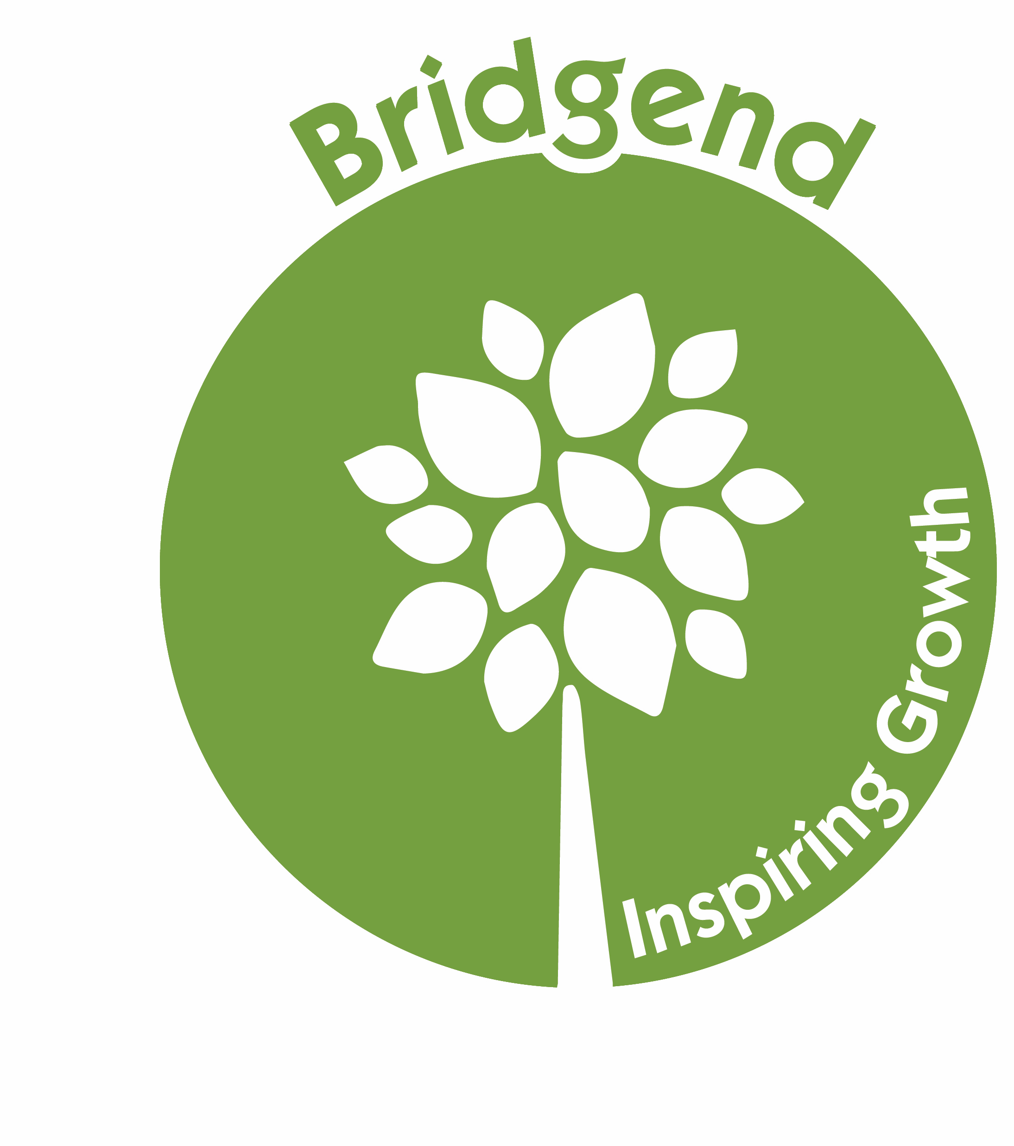
BIG Acorn Fund
Application Form

Who is involved (individual/group/member/etc):

Your Idea:

Why (including what BIG priorities it will meet):

Timeline:

Budget:

Address and Contact Details:

Anything else you would like to add:

