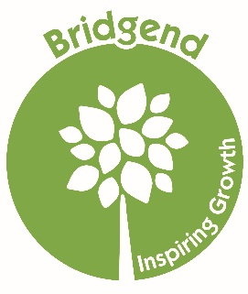
Bridgend Farmhouse Gift Aid Declaration

Boost your donation by 25p of Gift Aid for every £1 you donate

Gift Aid is reclaimed from the tax you pay for the tax year current to your donation.
Your address is needed to identify you as a current UK taxpayer.

Past, present and future donations to Bridgend Farmhouse

Please treat as Gift Aid donations all qualifying gifts of money made [tick/mark all appropriate]

Today In the past four years In the Future

Donor Details

Title First Name [or initials] Surname
Address
Town/ City Postcode

Please notify Bridgend Farmhouse if you:

- want to cancel this declaration
- change your name or home address
- no longer pay sufficient tax on your income and/or capital gains

If you pay income tax at the higher or additional rate and want to receive the additional tax relief due to you, you must include all your Gift Aid donations on your self-assessment tax return or ask HM Revenue and Customs to adjust your tax code.

Donor Signature Date

